**MINOR PROJECT REPORT**

**REAL TIME FACE MASK DETECTION**

**TEAM MEMBERS:-**

* Priyanshu (RA18110004010387)
* Sameer Ahad (RA1811004010391)

**GUIDE**

Dr. P. Vijaykumar Sir

**SOFTWARE AND LIBRARIES: -**

Software: Jupiter Notebook

Language: Python

Main Libraries: Sklearn, Opencv , Keras , Tensorflow

Database: Covid mask dataset

**ABSTRACT**

COVID-19 pandemic has rapidly affected our day- to-day life disrupting the world trade and movements. Wearing a protective face mask has become a new normal. In the near future, many public service providers will ask the customers to wear masks correctly to avail of their services. Therefore, face mask detection has become a crucial task to help global society. This paper presents a simplified approach to achieve this purpose using some basic Machine Learning packages like TensorFlow, Keras, OpenCV and Scikit-Learn. The proposed method detects the face from the image correctly and then identifies if it has a mask on it or not. As a surveillance task performer, it can also detect a face along with a mask in motion. The method attains accuracy up to 95.77% and 94.58% respectively on two different datasets. We explore optimized values of parameters using the Sequential Convolutional Neural Network model to detect the presence of masks correctly without causing over-fitting.

**WORKING**

The proposed system contains the following modules:

A. Pre-processing Images

B. Capture image

C. Upload image

D. Classifier(image)

E. Prediction(image)

**A. Pre-processing Images**

The input image is captured from a webcam or camera in real-time world. The frames (images)from the dataset are loaded. Face images are cropped and resized after they have been loaded. Later, noise distortions in the images are suppressed. Normalization is then done to normalize the images from 0-255 to 0-1 range.

**B. Capture image**

In this Module we are able to capture real time images. We do this by the help of Flutter and applying in to the Classifier Model.

Input: Nothing

**C. Upload image**

Here we can browse the image and upload for finding the Plant disease. We need to fetch the image. And this image passes to Classifier Module.

Input: Nothing

Output: Image

**D. Classifier(image)**

Following data Prepossessing of the images, will apply to the Classifier. Here it will find out the feature of the images. Mainly in this module feature extraction occurs. Image similarity features will be stored in to the model which gets created.

Input: Image

Output: Model

**E. Prediction(image)**

In this Module prediction of person take place. Here the browsed image will be placed in to the model and output will be shown as based on which label its get matched the most.

Input: Image

Output: Predicted Label

**SOURCE CODE:-**

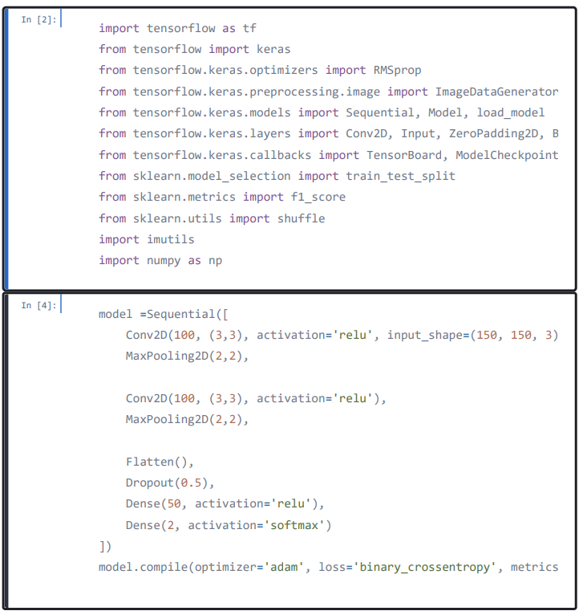

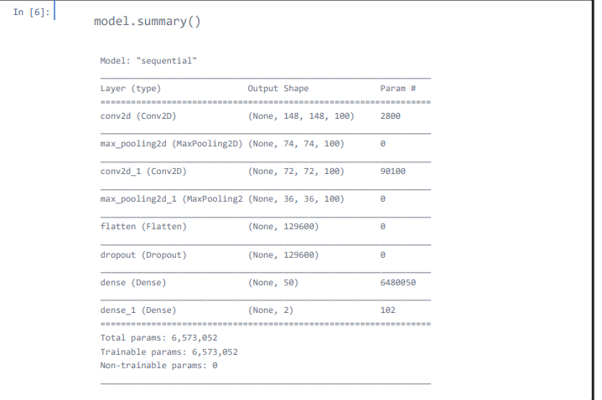

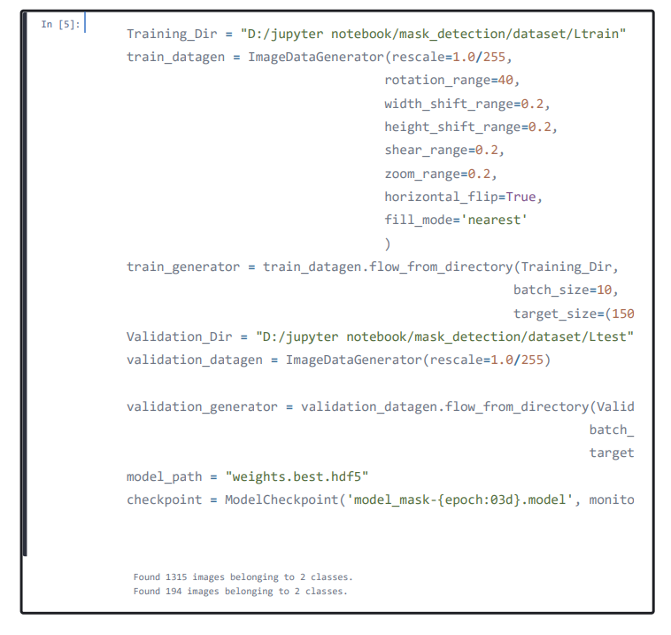

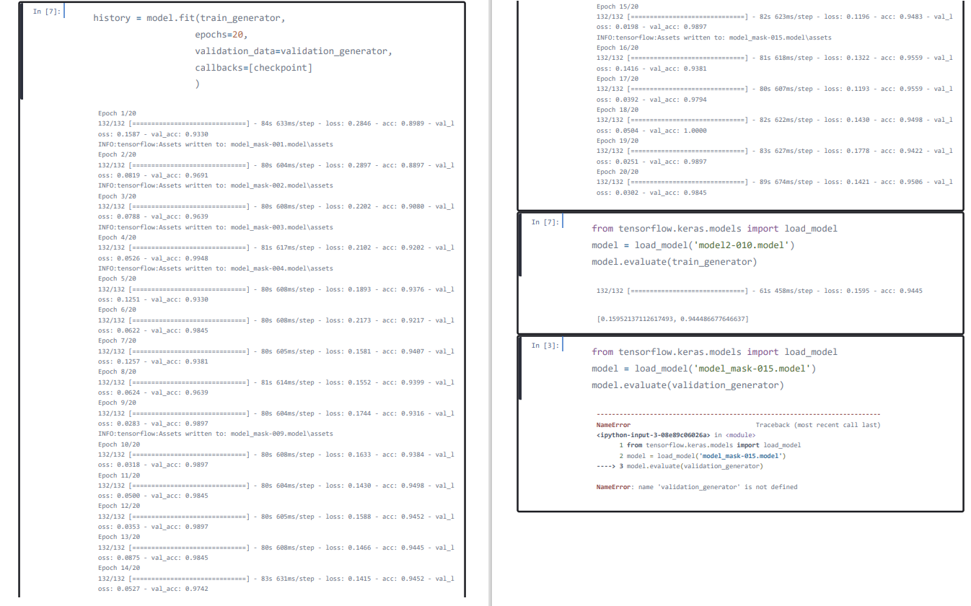

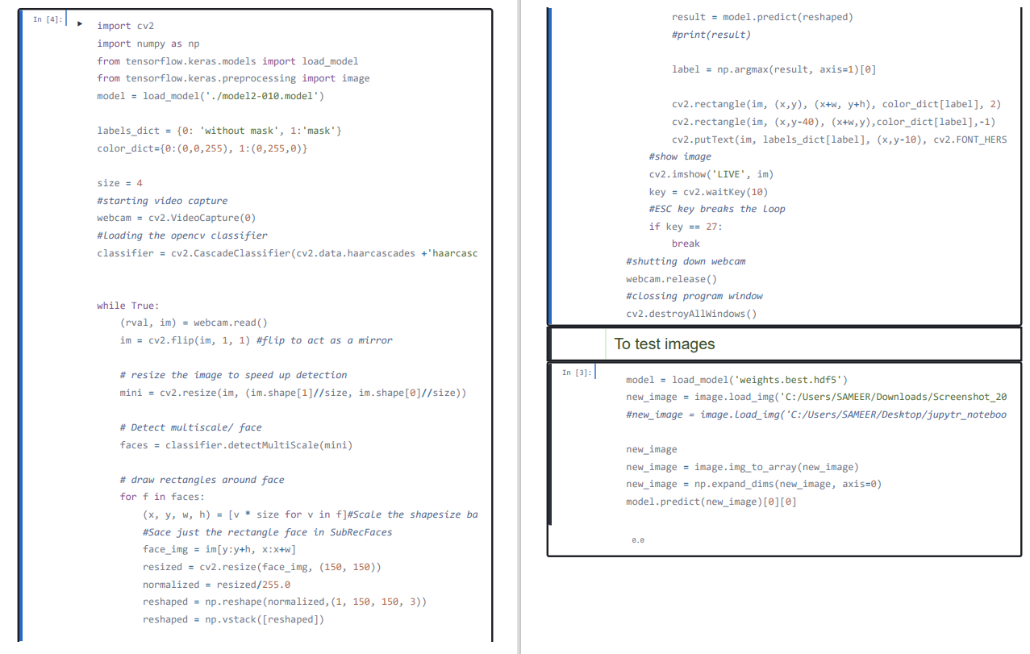

**OUTPUT/RESULTS:-**

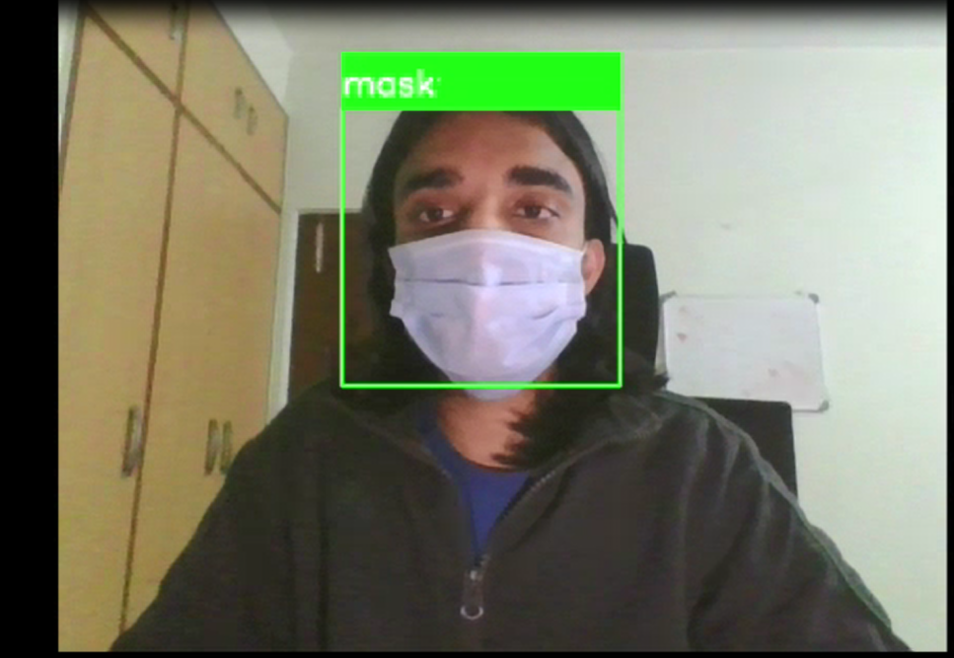

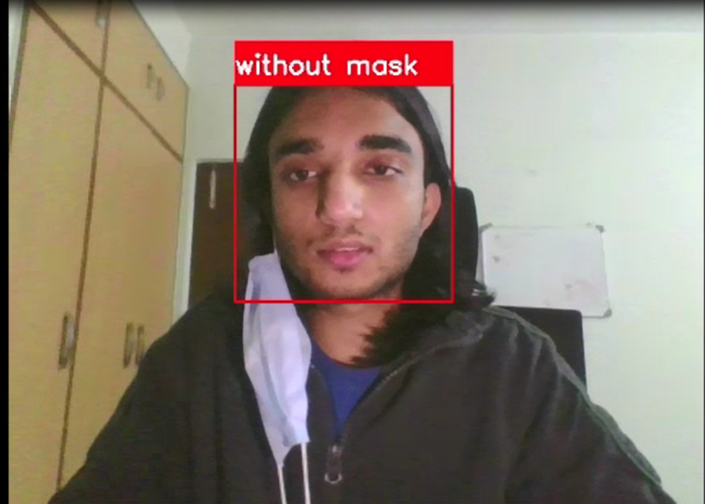

**LIMITATIONS AND FURTHER WORKS**

The developed system can detect the live video streams but does not keep a record. Unlike the CCTV camera footage the admin can not rewind, play or pause it. As whenever a strict system is imposed people always try to break it. Hence when a person is detected with no mask, the head of the organization can be notified via mail that so and so person entered without mask. The proposed system can be integrated with databases of respective organizations to keep a record of the person who entered without mask. With more complex functions a screenshot of the person’s face can also be attached to keep it as a proof.